|  |
| --- |
| InHarmsWay |
| Assignment 4: Side Scroller |
|  |
| Version 1.0  All work Copyright © 2013 by InHarmsWay Games.  All rights reserved. |
| **Andrew Harmathy** |
|  |



|  |
| --- |
| June 15th 2012 |

**Table of Contents**

Version History … page 3

Game Overview … page 4

Gameplay Mechanics … page 4

Controls … page 4

Interface Sketch … page 4

Game Progression … page 6

Menu and Screen Descriptions … page 7

Story Index … page 7

Art / Multimedia Index … page 8

Design Notes … page 8

Future Features … page 9

# Version History

*#Version 0.1: Enterprise ship is displayed and controllable*

*#Version 0.2: Power modules move across screen*

*#Version 0.3: Space background scrolls from right to left*

*#Version 0.4: Borg cube added. Scrolls right from random positions from the y-axis.*

*#Version 0.5: More borg cubes added. Background fixed to prevent skipping*

*#Version 0.6: Collision detection added. Pick-ups and borg ships disappear when touched by ship sprite*

*#Version 0.7: Intel sprites added. Power sprites will (in a future version) give health. Intel gives points.*

*#Version 0.8: Sounds added. Background music added.*

*#Version 0.9: Scoreboard added. Lives are tracked.*

# Game Overview

*The goal of the game is for the Enterprise to collect as much Intel they can without being destroyed by the Borg.*

# Game Play Mechanics

*The user uses the mouse to control the Enterprise and dodge Borg ships while at the same time collect Intel cubes. If the Enterprise takes on too much damage, it’s gameover.*

# Camera

*Camera view is side-view.*

# Controls

*The mouse is used to control the position of the ship avatar.*

# Saving and Loading

*N/A*

# Interface Sketch

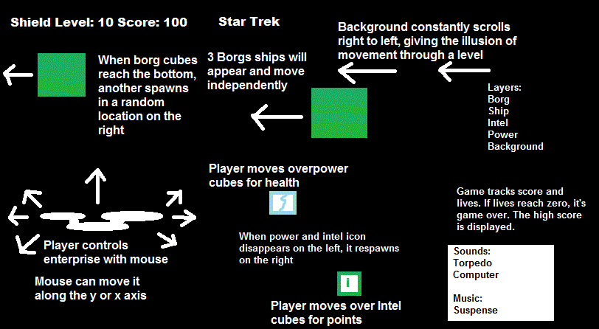

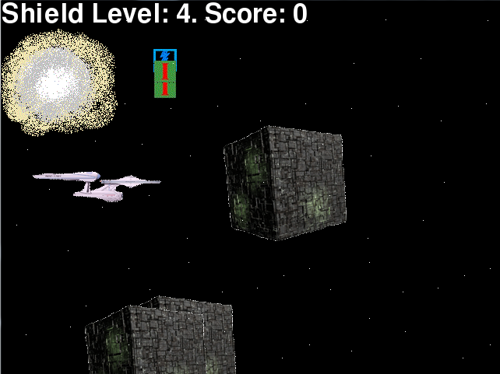

# Menu and Screen Descriptions

*Menu appears and explains the story. It also tells the user to either click their mouse to play the game or press esc to quit.*

*Start screen:*

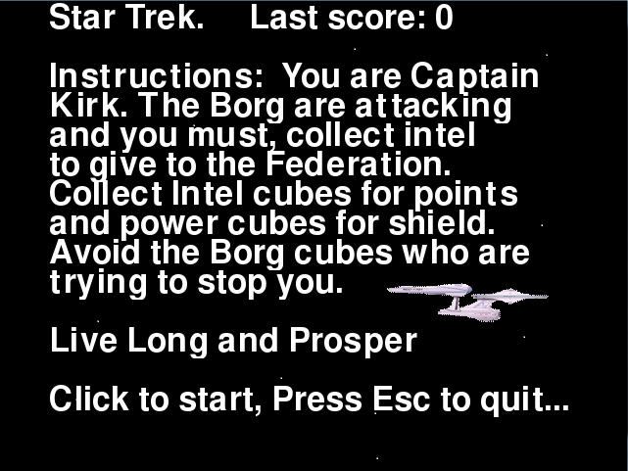

*Gameplay:*

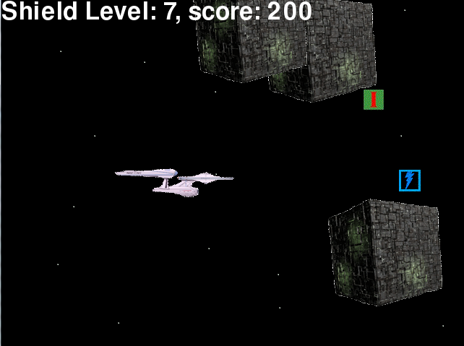

*End screen:*

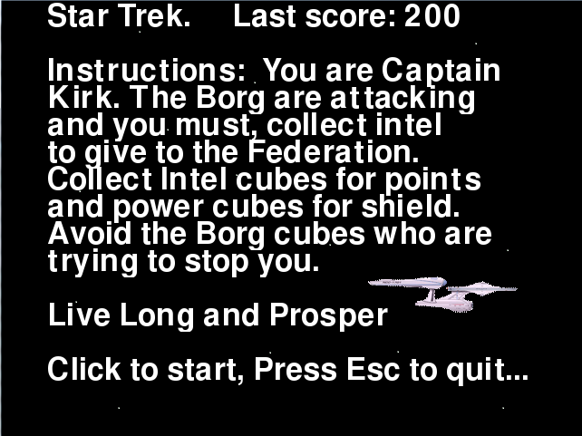

# Game World

Game takes place in the year 2266 in the same universe as the recent Star Trek movies.

# Game Progression

The user is has to gather Intel cubes for points. Their goal is to get as many points as possible.

# Characters

*Captain James T. Kirk. Captain of the USS Enterprise.*

# Enemies

*The Borg. A race of cybernetic beings that assimilate any life and information they come cross.*

# Items

*Intel cubes for points. Power cubes for shield.*

# Vehicles

The USS Enterprise, a Cruiser-class exploration vessel.

# Script

**N/A**

# Scoring

Player earns points by collecting Intel cubes.

# Sound Index

**Sound for contact with borg cube:**

**torpedo.ogg**

**Sound for game over:**

**urlifeisover.ogg**

**Sound for collecting items:**

**computer.ogg**

**Background music:**

**suspense.ogg**

# Story Index

*User wants to kill some time so they decide to bet some imaginary money on an imaginary game to win imaginary money.*

# Art / Multimedia Index

*Borg cube:*

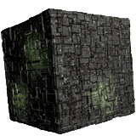

*Enterprise:*

*enterprise.gif*

*Power and Intel icons:*

*thunder.gifiicon.gif*

*space.gif:*

**

*spacetest.gif*

**

# Design Notes

*Issues arose in Version 1.0 where the program went haywire from me implementing the start and game over screens with my left-right side scrolling background sprite. Sprites started giving off trails. I was unable to get rid of this issue without switching the scrolling back to the original top-bottom scroll. All the other features work without problems.*

# Future Features

*In the future, I would like to fully implement the scrolling from right to left.*